

Electrical Engineering Technology (EET)

Embedded Plant Automation, Control, and Telemetry

By
Jack Watt

Senior Technical Report
Electronics Engineering Technology (EET)
2026

New Brunswick Community College – Saint John Campus
P.O Box 2270, Saint John, NB, Canada E2L 3V1
Phone: (506) 658 – 6600 Fax: (506) 643 – 2853
www.nbcc.ca
Departmental Disclaimer

This student’s Applied Research Project – consisting of this Report and a Formal Presentation received a passing grade. However, this report may contain errors, omissions, and inaccuracies.

Engineering Technology students seeking examples of proper Report techniques should consult any guide materials from your Communication course instructor, as well as your course textbook.

Jack Watt
900 Grandview Avenue
Saint John, NB
E2J 4C5
February 20, 2026
Saadmaan Rahman
950 Grandview Ave
Saint John, NB
E2J 4C5
Dear Saadman Rahman,
As part of the requirements for the Electronics Engineering Technology program at NBCC, I am submitting to you my Senior Technical Report. The project, which you approved, on November 14, 2025, features an automation system to aid in the growth and monitoring of various plants. The system will allow the end user to input the optimal growing conditions for whichever plants they want to grow.
The objective for this project is to build a physical system that will monitor soil moisture, air humidity and temperature, and pump water based on the soil level. There is also a requirement to turn the lights on and off on a schedule, with the possibility of including a light level sensor to be able to compensate for natural light. This would allow for the system to function on natural light when available but have the backup LED grow lights when needed.

A core part of this project is internet connectivity, allowing for the modification of the running configuration and parameters without taking the system offline, as well as the ability to log sensor data over time on a web server and then make decisions based on that data (e.g. being able to modify how much water is given to the plants when the soil is low based on various factors). This enables automation beyond simple programming logic and supports the use of a sliding window to determine optimal operating parameters.

I wish to extend my gratitude to you as well as Meghan Hayes, who helped with determining the scope of the project and advised on how to write the technical report. I have encountered many problems to which your help has been instrumental in helping decide the correct forward path for the project. I would be glad to answer any questions about this project and can be reached through email at jack.a.watt@gmail.com.

Sincerely,

**space for signature**

Jack Watt
Jack Watt
900 Grandview Avenue
Saint John, NB
E2J 4C5
February 20, 2026
Meghan Hayes
950 Grandview Ave
Saint John, NB
E2J 4C5
Dear Meghan Hayes,
As part of the requirements for the Electronics Engineering Technology program at NBCC, I am submitting to you my Senior Technical Report. The project, which was approved by Saadman Rahman, on November 14, 2025, features an automation system to aid in the growth and monitoring of various plants. The system will allow the end user to input the optimal growing conditions for whichever plants they want to grow.
The objective for this project is to build a physical system that will monitor soil moisture, air humidity and temperature, and pump water based on the soil level. There is also a requirement to turn the lights on and off on a schedule, with the possibility of including a light level sensor to be able to compensate for natural light. This would allow for the system to function on natural light when available but have the backup LED grow lights when needed.

A core part of this project is internet connectivity, allowing for the modification of the running configuration and parameters without taking the system offline, as well as the ability to log sensor data over time on a web server and then make decisions based on that data (e.g. being able to modify how much water is given to the plants when the soil is low based on various factors). This enables automation beyond simple programming logic and supports the use of a sliding window to determine optimal operating parameters.

I wish to extend my gratitude to you as well as Saadman Rahman, who helped with determining the scope of the project and advised on how to write the technical report. I have encountered many problems to which your help has been instrumental in helping decide the correct forward path for the project. I would be glad to answer any questions about this project and can be reached through email at jack.a.watt@gmail.com.

Sincerely,
**space for signature**
Jack Watt

Embedded Plant Automation, Control, and Telemetry



Senior Technical Report (1261-3286)

Embedded Plant Automation, Control, and Telemetry

By
Jack Watt

Applied Research Project Report
Electronics Engineering Technology (EET)
2026

New Brunswick Community College – Saint John Campus
P.O Box 2270, Saint John, NB, Canada E2L 3V1
Phone: (506) 658 – 6600 Fax: (506) 643 – 2853
www.nbcc.ca
Departmental Disclaimer

This student’s Applied Research Project – consisting of this Report and a Formal Presentation received a passing grade. However, this report may contain errors, omissions, and inaccuracies.

Engineering Technology students seeking examples of proper Report techniques should consult any guide materials from your Communication course instructor, as well as your course textbook.

TABLE OF CONTENTS

LIST OF FIGURES iv
LIST OF TABLES v
LIST OF APPENDICES vii
EXECUTIVE SUMMARY viii
1. Introduction 1
2.0 Project Overview 2
2.1 Physical Build 2
2.2 Electronics 2
2.3 Software 2
3.0 Research 3
4.0 Components 4
5.0 System Design and implementation 5
6.0 Software and code 6
6.1 software 6
6.1.1 wscat: used to remotely connect to the system 6
6.1.2 Tee-Object: Used to allow output to both the terminal and file 6
Works Cited 7
Appendix D: Code 9
(Draft note: some of this code was generated by AI, in the final submission which code I wrote and which I generated will be clearly explained. The gist though is that the web socket code was generated and almost everything else was written by hand. 9
This code is partly generated by AI. To save time I generated the web socket code using AI. I had a version that I wrote completely myself, but using this code helped to prevent the esp32 from disconnecting from the remote terminal. 9
The function for the web socket event was created using AI, and everything else I wrote myself or is example code or part of a library. 9
1: The physical system: 28
2: Configuring the code: 29
3: The Software and user interface 30
3.1 -Wscat wscat is a command-line WebSocket client. It establishes a connection to a server and provides an interface for transmitting and receiving messages over that connection. It is used in the project to be able to update the running conditions of the program without having to take it offline. Installation: In a powershell terminal run the following: npm install -g wscat Then, using the IP address of the plant automation system run: wscat -c ws://$IP where $IP is the the address of the plant automation system. Running: Now from here there are a few basic commands: lights on lights off water on water off start [time] [duration] Examples: lights on, lights off, water on, and water off all work as they sound. start 17:00 120 – this would turn the lights on at 17:00(5 PM) every day and would leave them on for 120 minutes. The system will set the time automatically based on the network time. 31

LIST OF FIGURES

LIST OF TABLES

LIST OF APPENDICES

APPENDIX A: ARP Approval Form
APPENDIX B: Progress Report
APPENDIX E: User manual

EXECUTIVE SUMMARY

This project presents the design and implementation of an embedded system for automating the growing of plants. The objective was to develop a functional prototype capable of monitoring environmental conditions and automating watering and lighting. The system was designed to integrate hardware control, embedded programming, and computer networking within a single platform.
The solution is built around an ESP32 microcontroller platform with integrated Wi-Fi capability. Monitoring is achieved using soil moisture sensors, air humidity and temperature sensors, an ambient lighting sensor, and a remote web server that will be making the decisions based on data communications from the ESP32.
A key feature of the system is remote connectivity. The ESP32 is in constant communication with a web server to retrieve operating parameters and configuration settings. This architecture separates control logic, data storage, and data analysis, allowing for remotely modifying the system parameters based on optimization strategies that have been implemented.
The prototype successfully integrates sensing, scheduling and wireless communication into a single embedded system. All primary functions – automated watering, scheduled lighting, and Wi-Fi communications -- are operational. The project demonstrates practical application of industrial control principles, power regulation design, embedded systems programming, and network communication within a scalable automation framework.

1. Introduction

Manual plant monitoring is both inefficient and inconsistent. With automation there can be improved reliability and scalability. This project explores implementing an embedded control system as a solution to monitoring and automation.
The system integrates sensors to measure environmental variables such as soil moisture, temperature, and humidity, allowing for continuous real time data collection and decision making. Based on the inputs provided, the system can make autonomous control decisions, such as turning on and off the lights and activating the water pump.
The system also integrates networking to allow for real time data retrieval and viewing, as well as the ability to change the running conditions of the system. It can be quite inconvenient to have to disconnect a system to update the conditions of the running program, which is why part of this system involves an interface to edit the conditions remotely without having to take the system offline.

2.0 Project Overview

The parts of the project:

- Physical Build
- Electronics
- Software

2.1 Physical Build

2.2 Electronics

2.3 Software

3.0 Research

Most of the research I did for this project consisted of how to connect and control the project remotely. I wanted to be able to set the running conditions of the project remotely, to be able to update the lighting and watering cycle without having to take the system offline to push new code to the ESP32.
Most of my components were cheap and not much thought went into picking them. I wanted to measure the soil moisture level, so I bought sensors for that. There wasn’t any effort put into comparing different sensors, I just bought what robotshop had because I have bought from them before.
I bought solid state relays. I already had some relays, but my advisor recommended solid state relays on the grounds that they are more reliable. I ended up picking two solid state relays from amazon that were cheap.
I picked the ESP32 because I already had it and because it has built in Wi-Fi.

4.0 Components

- Sht31 humidity and temperature sensor

5.0 System Design and implementation

6.0 Software and code

6.1 software

6.1.1 wscat: used to remotely connect to the system

6.1.2 Tee-Object: Used to allow output to both the terminal and file

Works Cited

[1] “SHT31 Weather-proof Temperature & Humidity Sensor Wiki - DFRobot,” Dfrobot.com, 2019. https://wiki.dfrobot.com/SHT31_Temperature_Humidity_Sensor_Weatherproof_SKU_SEN0385
[2] Sapry EL Gammal, “ph,” Scribd, 2026. https://www.scribd.com/document/609479894/ph (accessed Feb. 20, 2026).
[3] “RB-Dfr-191 Immersible Water Pump and Water Tube,” https://cdn.robotshop.com/media/d/dfr/rb-dfr-191/pdf/datasheet-fit0200.pdf.

APPENDIX A: ARP Approval Form

Source: Original

APPENDIX B: Progress Report

TO: Saadmaan Rahman
COPIES: Meghan Hayes
FROM: Jack Watt
DATE: 2026/02/06
SUBJECT: NBCC-SJ EET2 Senior Project – Progress Report #2
Project Title: Embedded Plant Automation, Control, and Telemetry
Period Covered: 2026/01/04 – 2026/02/06

PROJECT OBJECTIVE/OVERVIEW
As part of my plant growing and monitoring project, I am responsible for designing and implementing both the software and physical components of the system. I chose to work on this project because it incorporates many of the skills I have learned in my EET courses, as well as my previous experience. This project involves circuits and programming, which are core topics in my program. It also makes use of sensors, pumps, and lighting systems that align closely with the industrial control course I was taking with Rejean Bariault. My previous experience is in networking, computer programming, and web automation.

The objective for this project is to build a physical system that will monitor soil moisture, air humidity and temperature, and pump water based on the soil level. There is also a requirement to turn the lights on and off on a schedule, with the possibility of including a light level sensor to be able to compensate for natural light. This would allow for the system to function on natural light when available but have the backup LED grow lights when needed.

A core part of this project is internet connectivity, allowing for the modification of the running configuration and parameters without taking the system offline, as well as the ability to log sensor data over time on a web server and then make decisions based on that data (e.g. being able to modify how much water is given to the plants when the soil is low based on various factors). This enables automation beyond simple programming logic and supports the use of a sliding window to determine optimal operating parameters.
I have chosen an ESP32 as the platform to control the system, as it has built-in Wi-Fi.
I have yet to fully decide on what the enclosure will be or how big it will be, but I’m leaning towards a 40-gallon clear storage tote or larger. Ideally, I would use something like a terrarium for reptiles, as I think that would be the most ideal enclosure for my project, but for monetary reasons and practicality of this proof of concept, I think it would be best to build a system in something more affordable.
The benefit of the clear storage tote is that I can cut into the side of it and mount my in-soil sensors, which allows them to be in contact with the soil without exposing the electrical connections to the humid environment inside the enclosure.

WORK COMPLETED
So far, I have reached the first milestone, which includes having all my sensors, my pump, and my lighting running at the same time. When the soil moisture is low, it pumps water into the plants and turns on and off the lights on an 8-hour on, and 16-hour off cycle.
I’ve started to make my wiring neater and have cut my wires down to optimal lengths to be able to have the entire project contained in a small box. Eventually some of the wiring will need to be replaced because the sensors will be placed inside an enclosure with plants, while the rest of the system will be mounted to the enclosure in some way.
I currently have the Wi-Fi on the system working, which periodically scans a static web page looking for the running configuration of the system. Currently, the system is just checking for a single bit which indicates whether it should pump water. This simple code is the starting point for the rest of the code which will read the entire page, parsing it into lines, and then overwriting the default conditions of the system.

Background Material Collected:
- Read the data sheets and example code for my SHT31 humidity/temperature sensor
- Read an example code for the ESP32 Wi-Fi and HTTP libraries.
- Consulted with instructor Saadmaan about the use of a power circuit, which will use a 5v voltage regulator with a 6- and 12-volt battery to get both 5 volts and 3.3 volts. I’ll need at least 3.3v, 5v, and 9v+. Saadmaan helped to make the decisions on how to achieve this.

- Consulted prior instructor on industrial control principles, and ideas on how to achieve the project objectives.

PROBLEMS ENCOUNTERED
Most of the problems I’ve encountered had to do with the scope of my project. I pitched my idea without fully understanding the cost of what I wanted to build. Before the proposal was accepted, Saadmaan allowed me to scale the project back and remove the heating and fans I originally wanted. The reason these were removed is that in the humid environment I wanted to create, I would have needed special fans that can work while being wet, as well as I would have needed an enclosure that could handle heat. There is also the consideration that overheating the enclosure could be dangerous, even if I did have an appropriate enclosure. As a result, these aspects were removed to reduce cost and avoid potential safety risks.
The next problem I encountered is that the pH probe I bought was meant to be used with a solution made from distilled water and then maintained with a chemical that I wasn’t sure if I had to buy or make myself. This was an oversight on my part, because I meant to buy a pH sensor that could be stuck directly into the soil and give periodic readings. My advisor Saadmaan allowed me to remove it from my project.
The final problem I encountered is that while getting everything connected, I shorted my 12-volt battery and destroyed one of my solid-state relays.
Future Work
There is still a lot that could be done here.
Remote rather than local
Currently, there is a local connection over Wi-Fi to manage the automation system. Having the webserver run in the cloud rather than on a local machine would be a big improvement to the system. The local network works fine for demonstration, but moving the system to a web server hosted by amazon web services would be ideal. Right now the system can only be modified while on the same network as the automation system.
Watering system
An improved watering system would use a sprinkler to water the entire enclosure evenly. Or, another option would be a system that will allow water specific sections. Right now the system has a hose with holes in it to be able to water more than one area, but it doesn’t look good and it waters the areas unevenly.
Case layout
The case currently is quite messy. I’m using terminal strips to have a common 5v rail and a common ground. It would be neater and easier to maintain if a PCB were used. It would also be useful to write wrap each individual sensors wires. Right now, the soil sensors have 3 wires twisted together. They run from electronics case to the plant enclosure.
Improved soil sensor durability
The soil sensors have exposed electronics that aren’t corrosion resistant. They could be be protected with heat shrink tubing or there are more expensive soil moisture sensors that don’t have exposed electronics.
Improved lighting
There is currently one light which can have its position adjusted, but it would need to be adjusted multiple times per day to get the optimal lighting to the entire enclosure. The solution could be to buy more lights or to mount the light on a servo motor to have it slowly change its position over the length of its lighting cycle.
The same light I used in the project comes in a version that has multiple adjustable lights on it. I would suggest starting with that, as it’s probably the easier improvement to implement.
Eliminate multiple power sources
Right now there is a 12v battery, 6v battery, and USB charger. With a voltage regulation circuit, the water pump, lighting, and esp32 could be powered using the same source. It doesn’t make sense to have a product that requires three power sources.
Fix the water level circuit
The water level sensor currently is not reliable. Sometimes it detects the water and sometimes it doesn’t. The final version of my code has forced the system to always think the water sensor detects water, because I wanted my final demonstration to go well. I suspect the culprit is the lighting on the lab mixed with the fact it’s quite a cheap sensor. A better-quality water sensor could be used. This is an important update because if the water pump runs without water in the reservoir would most likely burn out the water pump.
Critical Alerts
Being able to receive an email or text message when something in the system is outside of an expected value should result in the end user being emailed or text messaged. The water reservoir being empty could be one, as well as if the soil moisture sensors register the soil outside of ideal ranges.
Nutrients
Currently there is nothing in place to feed the plants automatically. It would be possible to put something in the water reservoir, but ideally there would be another pump that could pump in nutrients.
Separate logging from remote access
Currently there is a connection made from a command line terminal which allows for sending commands to the system as well as for receiving updates on the system. Ideally these would be separate to allow for data logging when there is no remote connection.
Measure ambient lighting
The system currently can be set to turn the lights on for a duration every day. With a sensor to measure ambient lighting, it would be possible to not run the grow light if the system is receiving adequate natural lighting. This would allow for the system to only be operational when there isn’t enough natural lighting, which could save money.
Self-correcting behavior
The system currently will turn the water pump on for 5 seconds and then will wait 5 minutes to see if the moisture sensors have picked up the water added to the enclosure. This is a way to prevent overwatering, but with improved analysis, the system could use a PID loop to stabilize its outputs.
The main physical work I have left to do is to build a permanent enclosure for my plants and my system. All I need is the enclosure, as I have everything else. I’ll just have to replace some wires to make things longer to reach from the system to the enclosure.
After I complete the physical work, everything left will involve creating a web server that my ESP32 can talk to. This will allow for data logging, as well as getting the parameters of the system. Any decisions on how to modify the parameters of the program will happen on the web server, which will separate the system running the project from any data analysis, logging, or storage. One of the benefits of this is that if my system loses power for any reason, none of the data will be lost.

CONCLUSION
The scope of the project slightly changed from the first proposal until the final demonstration. Party because of issues that were encountered, but also to avoid potential issues that could occur. This was a project that tested and leveraged several areas of my study at NBCC. I choose to do a project on plant automation, because I saw it as an opportunity to get to program, build electronics, and try to incorporate the industrial control technology courses we had started around the beginning of this project. In the end I wouldn’t consider the project to leverage as much of the ICT courses as I would have liked, but I am satisfied that I successfully measured multiple environmental factors and responded to some of them.
The problems encountered with the circuits and building took away some of my time from programming. I didn’t initially intend to use AI to generate my websocket code, but as time went on in the program I saw it as a way to reclaim some of my lost time and focus more on the physical build and making the layout of the project as nice as possible. I still would like to improve the layout of the components in the enclosure, but how I have it now is about as good as it’s going to get without rewring parts of it, which I decided against. It seemed like a better plan to demonstrate the project with some messy wires than to end up with a non-fuctional project because I started rewiring at the last moment.
If I could go back and start over again I would put some time aside very early on to consider the layout of the final project. Being able to get that out of the way would have meant avoiding the mess I ended up with in the end, as well as I most likely wouldn’t have short circuited my SSR.
There were some objectives that had to be changed over time. When I started out there was going to be heating and a fogger. I quickly talked with my advisors to see if I could change the scope of the project because I was concerned about running a heater as it could melt my plant enclosure and start a fire if I made a mistake. I also was concerned about using the fogger because not everything in my project is made to used in wet humid environments. I ended up dropping both of these requirements to ensure that my project wouldn’t end up being lit on fire or damaged from water exposure.
I learned a lot from this project. There were times where I didn’t know how to continue or what was wrong with my circuit. There were multiple times where my code for one sensor or output device would block the rest of the program from executing. Being able to tell when this was happening helped me progress.

Appendix D: Code

This code is partly generated by AI. Almost everything for the communication between the esp32 and a terminal program was written by AI. Everything else was written by hand. All logic for the system was designed and implemented without AI.

#include <SPI.h>
#include <Adafruit_GFX.h>
#include <Adafruit_ST7735.h>
#include <Wire.h>
#include <DFRobot_SHT3x.h>
#include <WiFi.h>
#include <WebSocketsServer.h>
#include <time.h>

#define I2C_SDA 21
#define I2C_SCL 22

TwoWire I2CBus = TwoWire(0);
DFRobot_SHT3x sht3x(&I2CBus, 0x44);

#define TFT_CS 5
#define TFT_DC 2
#define TFT_RST 4

int lights_on = 1;
int water_on = 0;

int scheduledStartMinutes = 0;
int scheduledDurationMinutes = 0;
bool scheduleEnabled = false;

const int moistureTriggerPercent = 50;
const unsigned long wateringDurationMs = 5000;
const unsigned long wateringCooldownMs = 300000; // 5 minutes

bool autoWaterEnabled = true;
bool wateringPulseActive = false;
unsigned long wateringPulseStart = 0;
unsigned long lastWateringTime = 0;

Adafruit_ST7735 tft = Adafruit_ST7735(TFT_CS, TFT_DC, TFT_RST);

// WiFi
const char* ssid = "pump";
const char* password = "pump4duck123god$";

// WebSocket server on port 81
WebSocketsServer webSocket = WebSocketsServer(81);

int moisturePercent(int rawValue) {
const int wetValue = 1500;
const int dryValue = 3000;

if (rawValue <= wetValue) return 100;
if (rawValue >= dryValue) return 0;

return (dryValue - rawValue) * 100 / (dryValue - wetValue);
}

void webSocketEvent(uint8_t num, WStype_t type, uint8_t * payload, size_t length) {
switch (type) {
case WStype_DISCONNECTED:
Serial.printf("[%u] Disconnected\n", num);
break;

case WStype_CONNECTED: {
IPAddress ip = webSocket.remoteIP(num);
Serial.printf("[%u] Connected from %d.%d.%d.%d\n", num, ip[0], ip[1], ip[2], ip[3]);
webSocket.sendTXT(num, "ESP32 connected");
break;
}

case WStype_TEXT: {
String msg = String((char*)payload);
msg.trim();
Serial.printf("[%u] Received: %s\n", num, msg.c_str());

int water_level = digitalRead(34);
int soil_1 = analogRead(35);
int soil_2 = analogRead(32);
int soil1Percent = moisturePercent(soil_1);
int soil2Percent = moisturePercent(soil_2);

if (msg == "status") {
String reply = "";

struct tm timeinfo;
if (getLocalTime(&timeinfo)) {
reply += "time=";
if (timeinfo.tm_hour < 10) reply += "0";
reply += String(timeinfo.tm_hour);
reply += ":";
if (timeinfo.tm_min < 10) reply += "0";
reply += String(timeinfo.tm_min);
} else {
reply += "time=unavailable";
}

reply += ", lights_on=" + String(lights_on);
reply += ", water=" + String(water_level);
reply += ", pump_on=" + String(water_on);
reply += ", soil1_pct=" + String(soil1Percent);
reply += ", soil2_pct=" + String(soil2Percent);
reply += ", soil1_raw=" + String(soil_1);
reply += ", soil2_raw=" + String(soil_2);
reply += ", tempC=" + String(sht3x.getTemperatureC());
reply += ", humidity=" + String(sht3x.getHumidityRH());
reply += ", auto_water=" + String(autoWaterEnabled ? "on" : "off");

if (scheduleEnabled) {
reply += ", schedule=";
int schedHour = scheduledStartMinutes / 60;
int schedMin = scheduledStartMinutes % 60;
if (schedHour < 10) reply += "0";
reply += String(schedHour);
reply += ":";
if (schedMin < 10) reply += "0";
reply += String(schedMin);
reply += " for " + String(scheduledDurationMinutes) + " min";
} else {
reply += ", schedule=disabled";
}

webSocket.sendTXT(num, reply);
}
else if (msg == "lights on") {
scheduleEnabled = false;
lights_on = 1;
webSocket.sendTXT(num, "OK lights on");
}
else if (msg == "lights off") {
scheduleEnabled = false;
lights_on = 0;
webSocket.sendTXT(num, "OK lights off");
}
else if (msg == "water off") {
water_on = 0;
wateringPulseActive = false;
autoWaterEnabled = false;
webSocket.sendTXT(num, "OK water off");
}
else if (msg == "water on") {
water_on = 1;
wateringPulseActive = false;
autoWaterEnabled = false;
webSocket.sendTXT(num, "OK water on");
}
else if (msg == "auto water on") {
autoWaterEnabled = true;
webSocket.sendTXT(num, "OK auto water on");
}
else if (msg == "auto water off") {
autoWaterEnabled = false;
wateringPulseActive = false;
water_on = 0;
webSocket.sendTXT(num, "OK auto water off");
}
else if (msg == "schedule off") {
scheduleEnabled = false;
webSocket.sendTXT(num, "OK schedule off");
}
else if (msg.startsWith("start ")) {
int firstSpace = msg.indexOf(' ');
int secondSpace = msg.indexOf(' ', firstSpace + 1);

if (secondSpace == -1) {
webSocket.sendTXT(num, "invalid format, use: start HH:MM durationMinutes");
return;
}

String timeStr = msg.substring(firstSpace + 1, secondSpace);
String durationStr = msg.substring(secondSpace + 1);
timeStr.trim();
durationStr.trim();

int colonIndex = timeStr.indexOf(':');
if (colonIndex == -1) {
webSocket.sendTXT(num, "invalid time, use HH:MM");
return;
}

String hourStr = timeStr.substring(0, colonIndex);
String minuteStr = timeStr.substring(colonIndex + 1);

int startHour = hourStr.toInt();
int startMinute = minuteStr.toInt();
int durationMinutes = durationStr.toInt();

if (startHour < 0 || startHour > 23 || startMinute < 0 || startMinute > 59 || durationMinutes <= 0) {
webSocket.sendTXT(num, "invalid values");
return;
}

scheduledStartMinutes = startHour * 60 + startMinute;
scheduledDurationMinutes = durationMinutes;
scheduleEnabled = true;

String reply = "OK start set to ";
if (startHour < 10) reply += "0";
reply += String(startHour);
reply += ":";
if (startMinute < 10) reply += "0";
reply += String(startMinute);
reply += " for ";
reply += String(durationMinutes);
reply += " minutes";

webSocket.sendTXT(num, reply);
}
else {
webSocket.sendTXT(num, "unknown command");
}
break;
}

default:
break;
}
}

void setup() {
Serial.begin(9600);
I2CBus.begin(I2C_SDA, I2C_SCL);

while (sht3x.begin() != 0) {
Serial.println("Failed to initialize the chip, please confirm the chip connection");
delay(1000);
}

Serial.print("chip serial number: ");
Serial.println(sht3x.readSerialNumber());

if (!sht3x.softReset()) {
Serial.println("Failed to reset the chip");
}

if (!sht3x.startPeriodicMode(sht3x.eMeasureFreq_Hz5)) {
Serial.println("Failed to enter the periodic mode");
}
Serial.println("------------------Read data in cycle measurement mode-----------------------");

pinMode(34, INPUT);
pinMode(35, INPUT);
pinMode(32, INPUT);
pinMode(33, OUTPUT);
pinMode(25, OUTPUT);

SPI.begin(18, -1, 23, 5);

tft.initR(INITR_BLACKTAB);
tft.setRotation(1);
tft.fillScreen(ST77XX_BLACK);
tft.setTextWrap(false);
tft.setTextSize(1);
tft.setTextColor(ST77XX_WHITE, ST77XX_BLACK);

WiFi.begin(ssid, password);
while (WiFi.status() != WL_CONNECTED) {
delay(500);
Serial.print(".");
}
Serial.println();
Serial.print("WiFi connected, IP: ");
Serial.println(WiFi.localIP());

configTzTime("AST4ADT,M3.2.0,M11.1.0", "pool.ntp.org", "time.nist.gov");

Serial.println("Waiting for network time...");
struct tm timeinfo;
int attempts = 0;
while (!getLocalTime(&timeinfo) && attempts < 20) {
Serial.print(".");
delay(500);
attempts++;
}
Serial.println();

if (getLocalTime(&timeinfo)) {
Serial.printf("Time synced: %02d:%02d:%02d\n",
timeinfo.tm_hour, timeinfo.tm_min, timeinfo.tm_sec);
} else {
Serial.println("Failed to get network time");
}

webSocket.begin();
webSocket.onEvent(webSocketEvent);
}

void loop() {
webSocket.loop();

if (scheduleEnabled) {
struct tm timeinfo;
if (getLocalTime(&timeinfo)) {
int currentMinutes = timeinfo.tm_hour * 60 + timeinfo.tm_min;
int endMinutes = scheduledStartMinutes + scheduledDurationMinutes;

bool lightsShouldBeOn;

if (endMinutes < 1440) {
lightsShouldBeOn =
(currentMinutes >= scheduledStartMinutes && currentMinutes < endMinutes);
} else {
lightsShouldBeOn =
(currentMinutes >= scheduledStartMinutes ||
currentMinutes < (endMinutes % 1440));
}

lights_on = lightsShouldBeOn ? 1 : 0;

Serial.printf("Current time: %02d:%02d, schedule start=%02d:%02d, duration=%d, lights_on=%d\n",
timeinfo.tm_hour,
timeinfo.tm_min,
scheduledStartMinutes / 60,
scheduledStartMinutes % 60,
scheduledDurationMinutes,
lights_on);
}
}

int water_level = digitalRead(34);
int soil_1 = analogRead(35);
int soil_2 = analogRead(32);
int soil1Percent = moisturePercent(soil_1);
int soil2Percent = moisturePercent(soil_2);
float tempC = sht3x.getTemperatureC();
float humidity = sht3x.getHumidityRH();

unsigned long now = millis();

if (autoWaterEnabled) {
if (wateringPulseActive) {
if (now - wateringPulseStart >= wateringDurationMs) {
water_on = 0;
wateringPulseActive = false;
lastWateringTime = now;
Serial.println("Auto watering pulse finished");
}
} else {
bool cooldownFinished = (now - lastWateringTime >= wateringCooldownMs);
bool soilDry = (soil1Percent < moistureTriggerPercent || soil2Percent < moistureTriggerPercent);

if (cooldownFinished && soilDry) {
water_on = 1;
wateringPulseActive = true;
wateringPulseStart = now;
Serial.println("Auto watering pulse started");
}
}
}

digitalWrite(33, lights_on);
digitalWrite(25, water_on);

Serial.print("Water level: ");
Serial.println(water_level);
Serial.print("Soil1 raw: ");
Serial.print(soil_1);
Serial.print(" Soil1 %: ");
Serial.println(soil1Percent);
Serial.print("Soil2 raw: ");
Serial.print(soil_2);
Serial.print(" Soil2 %: ");
Serial.println(soil2Percent);
Serial.print("Temp (C): ");
Serial.print(tempC);
Serial.print(" Humidity (%RH): ");
Serial.println(humidity);

struct tm timeinfo;

tft.setTextColor(ST77XX_WHITE, ST77XX_BLACK);

tft.setCursor(0, 0);
if (getLocalTime(&timeinfo)) {
tft.print("Time: ");
if (timeinfo.tm_hour < 10) tft.print("0");
tft.print(timeinfo.tm_hour);
tft.print(":");
if (timeinfo.tm_min < 10) tft.print("0");
tft.print(timeinfo.tm_min);
tft.print(" ");
} else {
tft.print("Time: unavailable ");
}

tft.setCursor(0, 10);
tft.print("Water: ");
tft.print(water_level == 1 ? "YES" : "NO ");
tft.print(" ");

tft.setCursor(0, 20);
tft.print("Soil1: ");
tft.print(soil1Percent);
tft.print("% ");

tft.setCursor(0, 30);
tft.print("Soil2: ");
tft.print(soil2Percent);
tft.print("% ");

tft.setCursor(0, 40);
tft.print("TempC: ");
tft.print(tempC, 1);
tft.print(" ");

tft.setCursor(0, 50);
tft.print("Humid: ");
tft.print(humidity, 1);
tft.print(" ");

tft.setCursor(0, 60);
tft.print("Lights: ");
tft.print(lights_on ? "ON " : "OFF");
tft.print(" ");

tft.setCursor(0, 70);
if (wateringPulseActive) {
tft.print("Pump: ON ");
} else if (autoWaterEnabled) {
tft.print("Pump: AUTO");
} else {
tft.print("Pump: MAN ");
}

tft.setCursor(0, 80);
if (scheduleEnabled) {
tft.print("Sched: ");
int schedHour = scheduledStartMinutes / 60;
int schedMin = scheduledStartMinutes % 60;
if (schedHour < 10) tft.print("0");
tft.print(schedHour);
tft.print(":");
if (schedMin < 10) tft.print("0");
tft.print(schedMin);
tft.print(" ");
tft.print(scheduledDurationMinutes);
tft.print("m ");
} else {
tft.print("Sched: OFF ");
}

String updateMsg = "";
if (getLocalTime(&timeinfo)) {
updateMsg += "time=";
if (timeinfo.tm_hour < 10) updateMsg += "0";
updateMsg += String(timeinfo.tm_hour);
updateMsg += ":";
if (timeinfo.tm_min < 10) updateMsg += "0";
updateMsg += String(timeinfo.tm_min);
updateMsg += ", ";
}

updateMsg += "water=" + String(water_level);
updateMsg += ", pump_on=" + String(water_on);
updateMsg += ", soil1_pct=" + String(soil1Percent);
updateMsg += ", soil2_pct=" + String(soil2Percent);
updateMsg += ", soil1_raw=" + String(soil_1);
updateMsg += ", soil2_raw=" + String(soil_2);
updateMsg += ", tempC=" + String(tempC, 1);
updateMsg += ", humidity=" + String(humidity, 1);
updateMsg += ", lights_on=" + String(lights_on);
updateMsg += ", auto_water=" + String(autoWaterEnabled ? "1" : "0");

webSocket.broadcastTXT(updateMsg);
delay(1000);
}

APPENDIX E: User manual

The system mostly consists of a software terminal used to interact with system. Most of this user manual is going to consist of getting the software set up and making the connection between the terminal and the physical system.

1: The physical system:
- The light can be moved around to get the optimal distance from the plants.
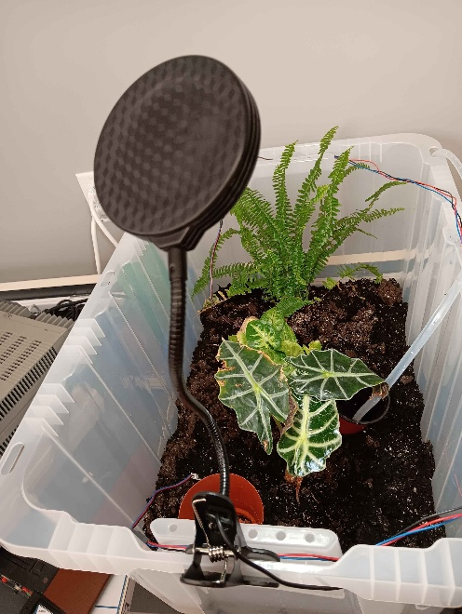

- The soil moisture sensors can be moved around the enclosure
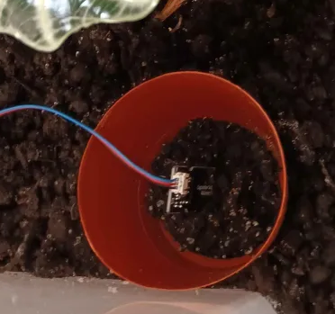
- The water pump can be positioned based on use case

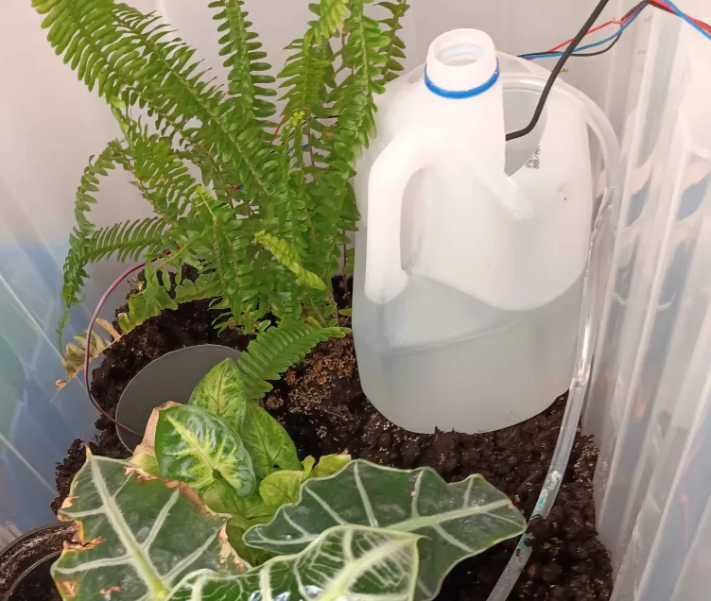

2: Configuring the code:

// WiFi
const char* ssid = "";
const char* password = "";
The only change that will need to be made to the code is to put in a wifi SSID and password.

3: The Software and user interface

3.1 -Wscat
wscat is a command-line WebSocket client. It establishes a connection to a server and provides an interface for transmitting and receiving messages over that connection. It is used in the project to be able to update the running conditions of the program without having to take it offline.
Installation:
In a powershell terminal run the following:
npm install -g wscat
Then, using the IP address of the plant automation system run:
wscat -c ws://$IP where $IP is the the address of the plant automation system.
Running:
Now from here there are a few basic commands:
lights on
lights off
water on
water off
start [time] [duration]
Examples:
lights on, lights off, water on, and water off all work as they sound.
start 17:00 120 – this would turn the lights on at 17:00(5 PM) every day and would leave them on for 120 minutes. The system will set the time automatically based on the network time.

Wiring Diagram

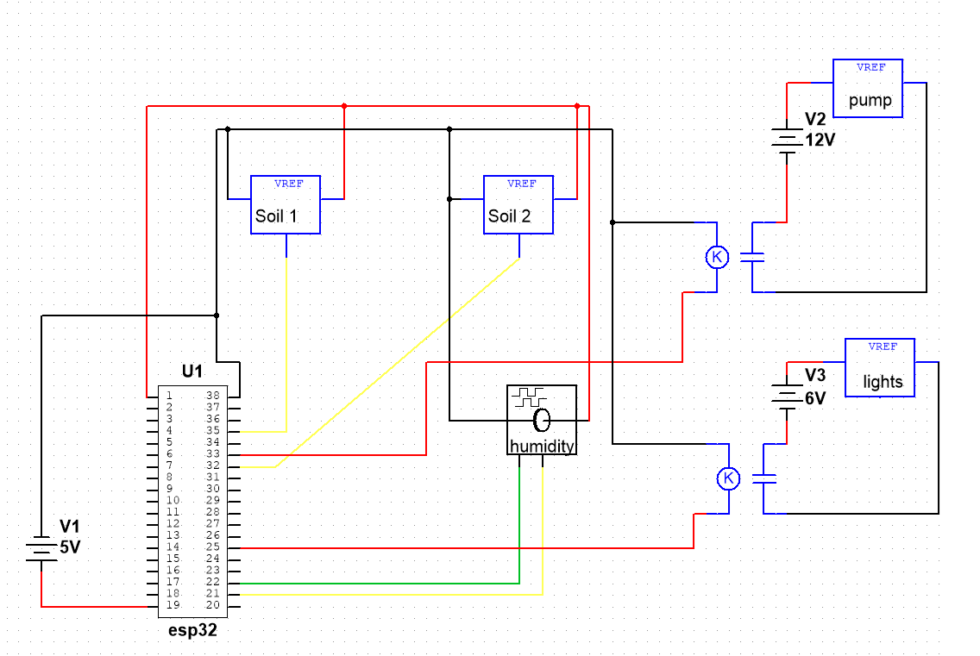

The esp32 is run from the 5v usb port or can be energized through pin 19. This system isolates the water pump and lights by building three separate circuits that have their grounds separated. This is achieved through the two solid state relays.
The system can be modified to use almost all of the remaining pins as inputs or outputs. Some pins have to be in a certain state at boot, so some are recommended not to use. It would be safe to add more soil sensors or sensors for other functions, it would just be advised to make sure not to excede the current limit for the esp32 pins. The soil and humidity sensors use around 5 mA each, which is why I’m powering them from the esp32. It could handle a few more, but it would make sense to power these sensors from the 5v supply directly, rather than through the 5v output pin on esp32.

